# How to restore a previous revision of DPX using TortoiseSVN

Changes to DPX should only be committed after rigorous testing. However, in case you find that the latest update of DPX breaks your experiment but you got to run one right away, SVN allows you to restore a working copy.

This guide describes how to restore a previous revision using TortoiseSVN on windows.

**Step 1:** Select “Update to revision …”

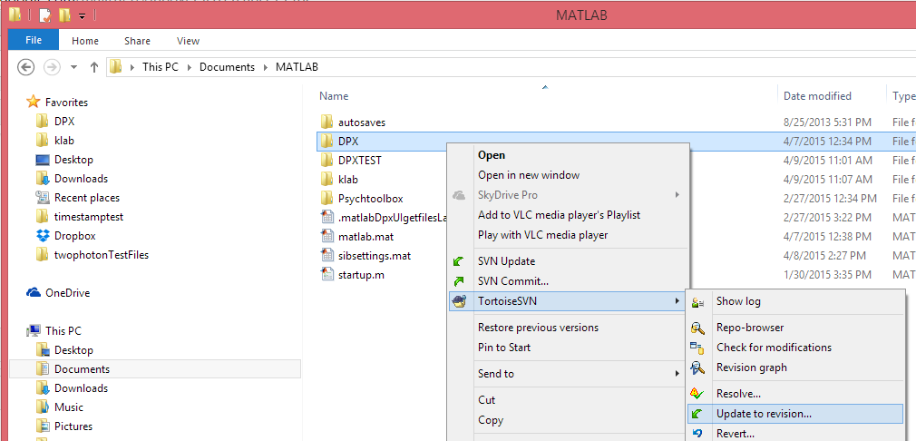

**Step 2:** Click “Show log”

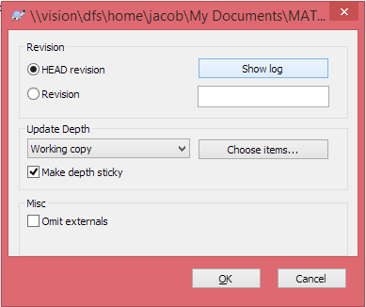

**Step 3:** Select a revision that you know worked for you last time (e.g. by date)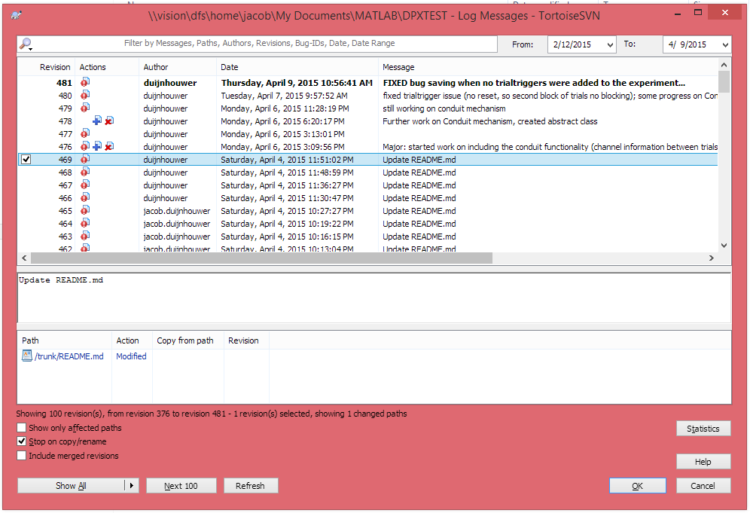

**Step 4:** The revision number is filled out automatically, click OK

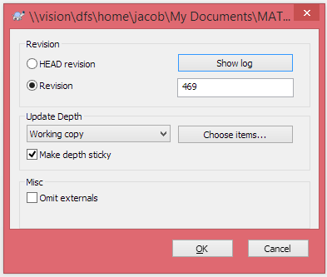

**Step 5:** Raise and Issue on <https://github.com/duijnhouwer/DPX/issues>

Explain how and when the latest update broke your experiment, and the number of the revision that does work for you.

